Artificial Intelligence Deep Machine Learning Thesis Proposal

Table of contents

Title 2
Abstract 2
Introduction 3
Thesis Problem Statement 11
Approach and Methods 12
Proposed Schedule 16
Bibliography 18

Author: Hoi Hon / M.S. Computer Science / Monmouth University /s1178590@monmouth.edu
Advisor: Prof. William Tepfenhart, PhD
Date: July 29, 2018

Title
Artificial Intelligence Deep Machine Learning with Human Intelligence and Phyllotactic Patterns

Abstract
Since the mid-20th century, Artificial Intelligence (AI) and Machine Learning (ML) have been the subject of significant studies. A lack of computing power held back investigations in these subject areas. Recently, maturing software technology coupled with easy accessible abundant computing hardware resources accelerated AI and ML developments. Advances in deep learning algorithms have made a number of possible breakthroughs in image recognition and learning. The typical goal of image processing is to recognize objects within the image. A large portion of this research has been influenced by the unique nature of digital imagery. This thesis focuses on computer visual deep learning from a new perspective that is influenced by how the brain and eye processing information from the real world.

Introduction
The past few years has seen the achievement of great advances in Artificial Intelligence (AI) and Machine Learning (ML) as illustrated by autonomous driving vehicles and automated trading systems. People have starting to compare the field of AI with the industrial revolution in the 18th Century. The industrial revolution touched almost every industry from textile, farming, and mining to transportation. The field of AI has just as much potential, or perhaps more, in terms of affecting every aspect of society. One key subject area in this revolution is that of computer vision. This thesis research will take an unconventional revolutionary approach in how images are analyzed.
Nature has had millions of years to develop efficient and effective vision systems while the area of computer vision has had decades. There is much to be learned from studying how nature has solved many of the vision problems. The eye-brain system can handle object recognition, motion detection, low light, color, black and white, object tracking, and other processing tasks. The eye is extremely complicated in its structure and function.
Digital images are usually generated and analyzed with grid-based or recto-linear geometries. That is, the sensors which generate the images are laid out in a grid and computer representations of those images are two dimensional arrays. Nature, on the other hand, doesn’t utilize orderly recto-linear geometries. Instead, nature tends to use structures based on the Golden Spiral. Familiar examples include Leonardo Da Vinci’s “Mona Lisa”, sea shells, universal galaxy spiral and spiral plants in the natural. The layout of the rods and cones on the back of the eye is illustrated in a plate from Pirenne (VISION AND THE EYE, Chapman & Hall, Ltd, 1967), which reproduced a drawing by Schultz (Schultz (1866), Arch. mikr. Anat, 2, 175) entitled, “The mosaic of the cones in the fovea centralis of human retina.” As can be seen from Figure 1, the cones are laid out in a phyllotactic structure.
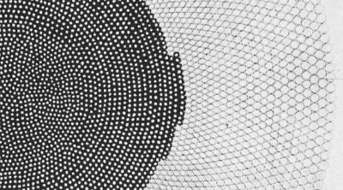
Figure 1 The mosaic of the cones in the fovea centralis of human retina (Schultz 1866).
Instead of fair weight values assigned to each convolution nodes in the Convolution Neural Network (CNN) layers, we will implement Golden Ratio weights in this research and study and find out the differences.
There are major differences in how the digital world and the average human handle images. For instance, in a digital camera, the incoming "picture" light hits the image sensor chip, which breaks it up into millions of pixels. The sensor measures the color and brightness of each pixel and stores it as a number. For human being’s vision, light rays enter the eye through the cornea, the clear front “window” of the eye. After passing through the iris, the light rays pass through the eye’s natural crystalline lens. In a normal eye as shown in figure 2, the light rays come to a sharp focusing point on the retina. The retina functions much like the film in a camera. It is responsible for capturing all of the light rays, processing them into light impulses through millions of tiny nerve endings, and then sending these light impulses through over a million nerve fibers to the optic nerve.

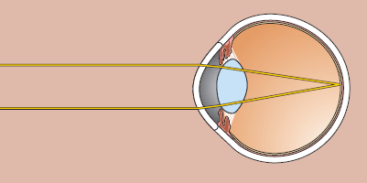
Figure 2 Light Entering Eyes in Normal Vision. (Neuroscience, 3rd edition)
The retina is actually part of the central nervous systems. Retina converts the lights into electrical impulses that if it is strong enough, the signal will travel to the brain via the optic nerve fiber. The retina contains fewer classes of neurons than the central nervous system. The retina cells are arranged in a way that is easier to separate than the more complicated nerve cells around the brain.

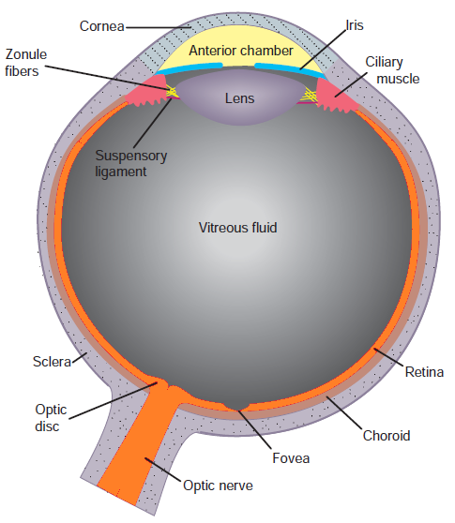

Figure 3 Anatomy of the Human Eye.
(Fundamental Neuroscience, 3rd edition)

In all types of cells, there is an electrical potential difference between the inside of the cell and the surrounding extracellular fluid. This is termed the membrane potential of the cell. While potential difference occurrence is present in all cells, it is especially important in nerve and muscles cells, because changes in their membrane potentials are used to code and transmit information. In the retina, the magnitude of a graded potential is determined by the strength of the stimulus. Light activation causes a graded change in membrane potential and a corresponding change in the rate of transmitter release onto postsynaptic neurons. Postsynaptic neuron is a neuron to the cell body of which an electrical impulse is transmitted across a synaptic cleft by the release of a chemical neurotransmitter from the axon terminal of a presynaptic neuron. Figure 4 illustrated an intracellular recording from a single cone stimulated with different amounts of light. The membrane potential was recorded between -40mV and -65mV during a light flash into the eye.

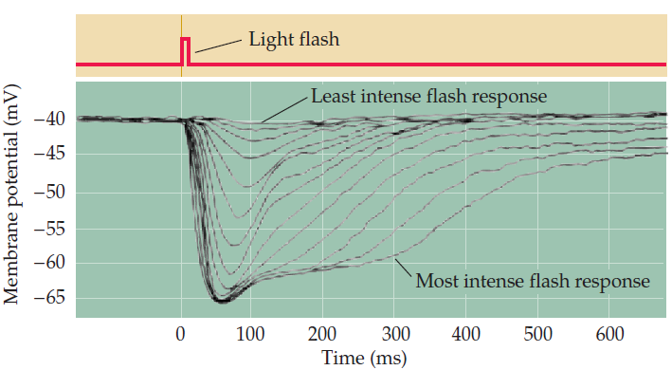

Figure 4 Phototransduction Intensity (After Schnapf and Baylor, 1987.)

Phototransduction is the sensory transduction of the visual system. It is a process by which light is converted into electrical signals in the rod cells, cone cells and photosensitive ganglion cells of the retina of the eye. During phototransduction, a biochemical surge that controls the ion channel’s opening and closing in the membrane of the photoreceptor’s outer segments where the cones and rods of the retina handles the capacity of the eye to see fine detail measured by determining the finest detail that can just be detected. Other than the cones and rods, retinal ganglion cell is one of the most important photoreceptor cells. Each retina possesses some 1 to 2 million ganglion cells that are distributed throughout the retina. The Center surround ganglion cell antagonism enables edge detection and contrast enhancement within the visual cortex. The ganglion cell is sensitive to luminance contrast and relatively insensitive to the overall level of illumination. The layout and tightly coupled structure between the synaptic interactions between photoreceptors, bipolar cells, and horizontal cells in the outer plexiform layer allow the retina to deliver already highly processed visual images when the signal reached the visual centers in the brain as shown in figure 5.
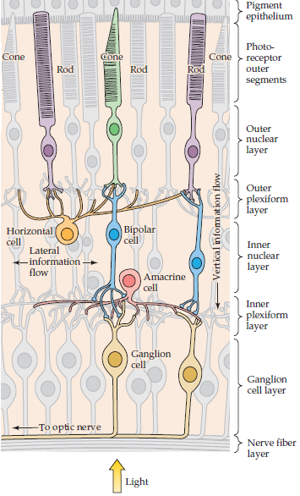
Figure 5 Basic circuitry of the retina of how light and dark are handled
by Cone and Rod Photoreceptors. (Neuroscience 3rd Edition)
Stephen William Kuffler ((August 24, Hungary, 1913 – October 11, 1980) was a pre-eminent Hungarian-American neurophysiologist. He is often referred to as the "Father of Modern Neuroscience". While he was working at Johns Hopkins University in the 1950s, he pioneered the approach by characterizing the responses of single ganglion cells in the cat retina. He found that each ganglion cell responds to stimulation of a small circular patch of the retina, which defines the cell’s receptive field. Based on these responses, Kuffler found two classes of ganglion cells, on-center and off-center. The response of ganglion cells to light patterns illumination intensity of the surrounding areas of the retina. The convergence of the input from bipolar cells onto ganglion cells and is partly produced by integrative functions of the horizontal cells. Ganglion cells response to light with on- or off-centers is shown in Figure 6.

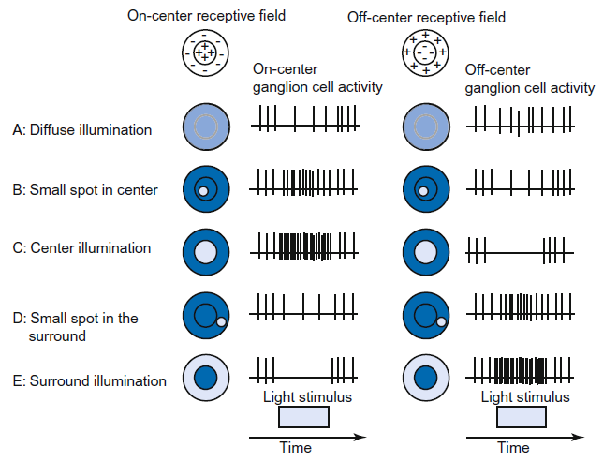
Figure 6 Effect of the size and position of a light stimulus
on the response of on-center ganglion cells and off-center ganglion cells.
(Feher, J. (2012). Quantitative Human Physiology)

Not only is the image intake process much more complicated in human’s eyes, how we look at an image is also dissimilar than in the digital world. The digital neural network samples the image pixel by pixel and frame by frame. The information collected then passes through a series of layered networks for a single answer. On the contrary, our brain is accustomed to the “Cognitive Laziness”, as in when an object attracts our eyes, surprisingly while it feels like we’re looking at the entire piece as one, but our eyes are actually jumping around from point to point, like a water strider on the surface of a pond. These micro-adjustments are known as “saccades,” and they are at the core of our visual perception and how we build the world around us as shown in figure 7. Saccades construct the reality of experience.

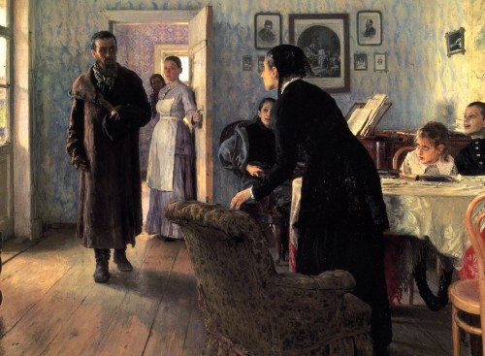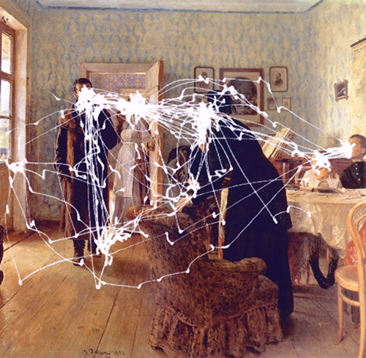
Figure 7 Tracking the Gaze - “Saccades”. An example of Yarbus’s eye tracking studies, circa 1967.
Human minds are remarkable when recognizing anything that fits into pre-ordered patterns. We can also react based these pre-ordered patterns. For example, an object is thrown to a person at a high speed; the person’s initial visual response is not to analyze what the type of flying object is coming to them and what are other objects in the background. Instead, the person’s initial reaction is to duck his head, catch it or run immediately depending on the pre-ordered pattern matching at the time. Human make leaps in thinking and assumptions to find the answers from our mind. This is also referred to “lazy” heuristics. However, if we rely too much on using our existing heuristic patterns without modifying them we can create a state of mental stagnation. This is sometimes called “Cognitive Laziness” or cognitive dissonance.

Besides, according to Charles Sanders Pierce’s (10 September 1839 – 19 April 1914, he is an American philosopher, logician, mathematician, and scientist) “Theory of Signs”, there are three interrelated areas, a sign (symbol), an object (e.g. image) and a concept (idea, interpretation in mind). Every thought is a sign and every act or sort of reasoning consists of an interpretation of the sign. Sings function as mediators between the external world of the objects and the internal world of ideas. Speaking of signs, Semiosis is the process of co-operation between signs. Everyone is a semiotician, because everyone is constantly unconsciously interpreting the meaning of signs around them. There is no direct relation between symbols and image. Concept will bridge the symbol and sign in reality.
This thesis will utilize the symbol, concept and image relationship in the “Theory of Signs” to analyze the input images and store them in a cluster in the AI system until these images are categorized similar to how the human brain learns and process images from the environment.

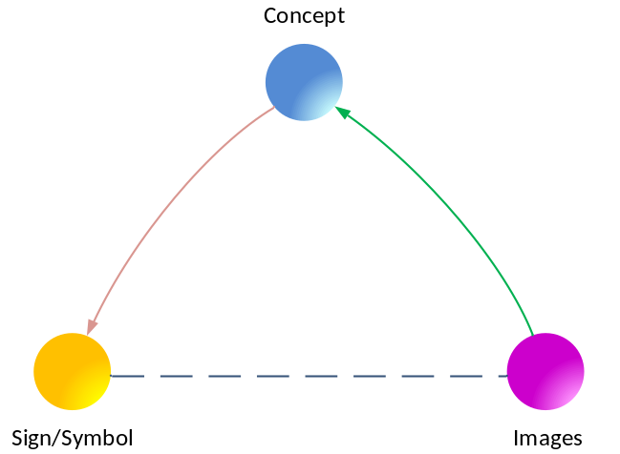
Figure 8 Charles Sander Pierce’s “Theory of Signs”

Thesis Problem Statement

Most of the artificial AI visual recognition systems used today generally scan through grids of pixels and filter the pixel data through a series of Convolution Neural Network layers. It does this to analyze and find matching patterns with a set of training data already loaded into the system. The training data set is required to be manually pre-categorized in order for the AI system to learn from the data.
In comparison, the artificial neural network weighs each of the pixels fairly based on the brightness of the pixel. However, in the “natural” world, our eyes do not weigh every pixel of the image we see in a fair way. In fact, we gave preferential weight to objects with a Golden Ratio higher than the one does not have the ratio. Our brain naturally provides more attention (weight) to numbers, objects related to Golden Ratio, such as Fibonacci and logarithmic, etc.
There is at least couple of challenges in using the common AI neural network analysis today. First, what course of action should the AI neural network take if there is no or insufficient training data in the system? Since without proper training data, the analysis result is almost certain to be wrong. Second, when human looks at an image, we may not be interested in any or may be only one or two objects that attract our eyes from the image instead of all the glory details. When an object attracts our eyes, the object will be reflected into our cornea and into our retina and the pluses triggered signal will be pass through the human neural network. Human brain will group and store similar object images in a cluster in the proximity memory area until human obtains knowledge of the objects. However when lacking training data, an artificial network will either outputs a wrong or right answer. It is most likely that the output is the wrong one. Besides, imagine an AI system is deployed in a totally foreign environment, for example on Mars, where the AI system will have many opportunities to learn new objects. In 2022, NASA is launching a demonstration mission to Mars will be launched to provide proof of concept for some of the technologies that are crucial for Mars-One’s human mission to Mars. By 2031, the first crew of astronauts will start their journey to Mars and become permanent human settlers on Mars. There will be mass amount of new images to recognize in such an environment. Should an AI system try to identify these objects in the image, or should the AI system get rid of these unknown objects or should it store the objects like the human brain stores it for future use?

Approach and Methods

This research utilizes Google’s TensorFlow open source deep machine learning framework for training and testing that involves weights, biases, Sigmoid, ReLU, Gradient Descent, and cost functions. The standard Google TensorFlow CNN framework will be used to analyze different input images. One set of images takes the default recto-linear approach frame-by-frame with image learning neural network analysis. Another set of image input source data will be altered using Golden Ratios. The second set of images takes the unconventional approach that mimics how human eyes and brain reading a painting in art gallery. As our eyes focus on the “rich” area of the painting, the “saccades” approach and the results will be compared with the results from more conventional approaches. In addition, the Golden Ratio weight will be considered in the neuron calculations. The two sets of analysis results will be compared and summarized.
In addition to the thesis, there will be two research papers included:
1st research paper – The “Saccade” effect in Artificial Intelligence
2nd research paper – The relationship between Golden Ratio and Artificial Intelligence
For instance, phyllotactic patterns exist in the natural world for millions of years. It does not seen to be special when an object is overlaid with the pattern. However, interestingly, when the overlapping portion of the object is expanded and flatten into a 2-dimensional grid pattern, we see a wedge pattern similar to stock ticker move.
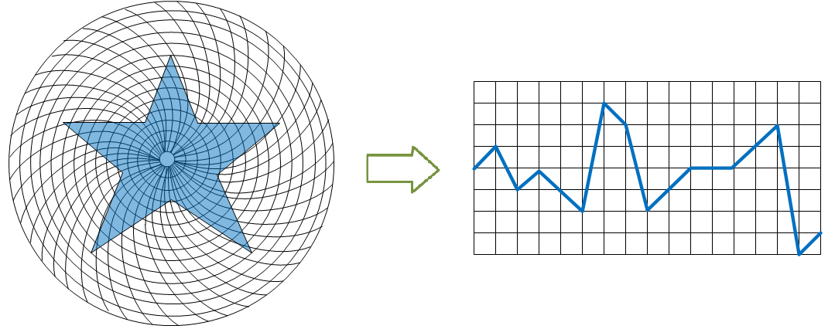
Figure 9 Example of using Phyllotactic Structure in Deep Learning

Due to the complexity of the following subject areas, I will focus on the first four areas, detector, image layout, sampling, initial weight seeding and touch on the other areas when necessary in the implementation.
Actions | Digital Vision World | Real World
Detector | Silicon-based light detector | Light sensitive nerve cells
Image Layout | Recto-linear Images | Phyllotactic Structure
Sampling | Convolutional Sampling | Saccades
Initial Weight Seeding | Fair Weightings | Natural Weightings (Golden Spiral, Golden Ratio, Fibonacci, logarithmic)
Training data | Training and test data set | No explicit training data, just data
Dynamic World | Single image training | Video images
Data processing | Convolutional sampling | ‘real world version’
Acquisition | Timely matter | Slow acquisition
Learning | Training phase/applied phase | Integrated learning
Categorization | Artificial applied categories | Natural categories
Determinism | Single answer | Optical Illusions (evolving answer)
Table 1 Area of Interest for human-like AI System
Detector - in a digital camera, the incoming "picture" light hits the image sensor chip, which breaks it up into millions of pixels. The sensor measures the color and brightness of each pixel and stores it as a number. Your digital photograph is effectively an enormously long string of numbers describing the exact details of each pixel it contains. Light rays enter the eye through the cornea, the clear front “window” of the eye. After passing through the iris, the light rays pass thru the eye’s natural crystalline lens. In a normal eye, the light rays come to a sharp focusing point on the retina. The retina functions much like the film in a camera. It is responsible for capturing all of the light rays, processing them into light impulses through millions of tiny nerve endings, and then sending these light impulses through over a million nerve fibers to the optic nerve.
Image layout - in the digital world, what the neural network product is pin pointing for a single answer whether this is as simple as recognizing a hand written numbers or alphabets all the way to more sophisticated Monte Carlo deep learning. They produce a single guessed output. However, in the real world, human’s eye or mind create optical illusion when we look at an object, in some case, there is never a single answer our brain tell us. We often have illusions that the object we see appears to differ from reality. The illusion can be caused by variations in brightness, color, position, size and movement.
Sampling - in the digital world, the neural network samples the image pixel by pixel and frame-by-frame. The information collected then passes through a series of layered network for a single answer. When human looking at an image, it feels like we’re looking at the entire piece all at one, but what our eyes are actually jump around from point to point, like a water strider on the surface of a pond. These micro-adjustments are known as “saccades,” and they are at the core of our visual perception and how we build the world around us. Saccades construct the reality of experience.
Initial Weight Seeding - the artificial neural network weights each of the pixels fairly base on the brightness of the pixel. However, in the natural world, our eyes do not weight every spot of the image we see in a fair way. In fact, we gave preferential weight to objects with Golden Ratio higher than the one does not have the ratio. Our brain naturally provides more attention/weight to numbers, objects related to Fibonacci and logarithmic.
Training Data - there a training set and test set of data in the artificial neural network to ensure the answer is properly trained and tested. I don’t recall when I was young, my parent line up 10 spoons or folks on the table and tell me to recognize (train) these are spoons before my meal. I will have to pick up the data progressively over the years from different environments presented to me.
Dynamic World – in the digital world, training data is provided to the AI system one frame at a time. All these training data are pre-sorted and pre-categorized for training purposes. It involve many hours with many resources in the categorization tasks. In the real world human never taking a static image to analyze, our eyes are constantly moving as all the images we see are in a video format. We don’t have the concept of training data verses test data.
Data Processing - in the convolutional sampling, the convolution layer comprises of a set of independent filters. Each filter is independently convolved with the image. As we go deeper to other convolution layers, the filters are doing dot products to the input of the previous convolution layers. So, they are taking the smaller colored pieces or edges and making larger pieces out of them. In the real world, human use the saccades to filter the image and the image then matches with our memory from the progressive and integrated learning over the years where these images stored in similar area in our brain.
Acquisition - in the deep learning world, when lacking enough data for the training, the outcome can be way off from the actual answer and product a wrong answer. The deep learning process will not be able to auto-correct simply there is not enough information for correction. In the real word, we acquire knowledges of an object and image slowly. Overtime, we build up sufficient data to support the recognition.
Learning - the integrated learning will be overtime, for instance, if the image is learned once, the neural network may not know what it is. Somehow, something has to know to categories it to the content for next image learning.
Categorization - for a neural network to function there is manual process to categorize many sets of pre-sorted images. This is a lengthy and costly process to prepare the data. In order for a neural network to recognize 100 objects, a set of 100,000 pre-categorized images may require for the training in order to have a high probability correct answer. Human acquire these objects and images gradually and store them in the memory. The researchers found that, for instance, the brain organizes the categories of “humans” and “animals” in a related manner, whereas “eyeball” and “car” are stored in completely different areas of the brain. Along with finding out how the brain organizes different categories of objects, the researchers also found out that different people’s brains organize things in similar ways.
Determinism - the images we see today, our digital usually analyze with grid-based or retro-linear way instead of analyzing using Golden Spiral dimension. If we pay attention to our surroundings, we will surprise ourselves that many objects including images are closely related to the Golden Spiral. The famous photos including Leonardo da Vinci’s Mona Lisa, the universal galaxy spiral to the spiral plants in the natural.

Proposed Schedule

This thesis is estimated to be completed in one year (fall and spring academic semesters). The proposed 2018 fall semester tasks and schedule is as follows:
 |  |  |  | 2018 Fall
 | Week 1 | Week 2 | Week 3 | Week 4 | Week 5 | Week 6 | Week 7
 | 9/4/2018 | 9/10/2018 | 9/17/2018 | 9/24/2018 | 10/1/2018 | 10/8/2018 | 10/15/2018
Setting up operating system and install TensorFlow
Download, organize training, testing data
Setting up neural network environment
Break video into picture frames
Perform retro-linear learning
Create saccades algorithms
Training with Golden Spiral samplings
Comparing Golden Spiral results with retro-linear results
Saccade research paper
Golden Spiral research paper
Summary report in Word documentation and Power Point
 | Week 8 | Week 9 | Week 10 | Week 11 | Thanksgiving | Week 12 | Week 13 | Week 14
 | 10/22/2018 | 10/29/2018 | 11/5/2018 | 11/12/2018 | 11/19/2018 | 11/26/2018 | 12/3/2018 | 12/10/2018
Setting up operating system and install TensorFlow
Download, organize training, testing data
Setting up neural network environment
Break video into picture frames
Perform retro-linear learning
Create saccades algorithms
Training with Golden Spiral samplings
Comparing Golden Spiral results with retro-linear results
Saccade research paper
Golden spiral research paper
Summary report in Word documentation and Power Point
Table 2 – Fall 2018 Schedule for Deep Learning Programming

The proposed 2019 spring semester tasks and schedule is as follows:
 |  |  |  | 2019 Spring
 | Week 1 | Week 2 | Week 3 | Week 4 | Week 5 | Week 6 | Week 7
 | 1/22/2019 | 1/28/2019 | 2/4/2019 | 2/11/2019 | 2/18/2019 | 2/25/2019 | 3/4/2019
First draft
Detailed editing
PowerPoint presentation
5 minutes demo video
Final presentation to committee
 | Week 8 | Spring Break | Week 9 | Week 10 | Week 11 | Week 12 | Week 13 | Week 14
 | 3/11/2019 | 3/18/2019 | 3/25/2019 | 4/1/2019 | 4/8/2019 | 4/15/2019 | 4/22/2019 | 4/29/2019
First draft
Detailed editing
PowerPoint presentation
5 minutes demo video
Final presentation to committee
Table 3 – Spring 2018 Schedule for Thesis Writing

Bibliography

Atkin, A. (2013, July). Peirce's Theory of Signs. Retrieved from Stanford Encyclopedia of Philosophy: https://plato.stanford.edu/entries/peirce-semiotics/#Bib
Peirce's Sign Theory, or Semiotic, is an account of signification, representation, reference and meaning. Although sign theories have a long history, Peirce's accounts are distinctive and innovative for their breadth and complexity, and for capturing the importance of interpretation to signification. For Peirce, developing a thoroughgoing theory of signs was a central philosophical and intellectual preoccupation. Peirce also treated sign theory as central to his work on logic, as the medium for inquiry and the process of scientific discovery, and even as one possible means for 'proving' his pragmatism. Its importance in Peirce's philosophy, then, cannot be overestimated.

Courville, I. G. (2018). Deep Learning. Boston: An MIT Press book.
The text offers mathematical and conceptual background, covering relevant concepts in linear algebra, probability theory and information theory, numerical computation, and machine learning. It describes deep learning techniques used by practitioners in industry, including deep feedforward networks, regularization, optimization algorithms, convolutional networks, sequence modeling, and practical methodology. This book offers research perspectives, covering such theoretical topics as linear factor models, autoencoders, representation learning, structured probabilistic models, Monte Carlo methods, the partition function, approximate inference, and deep generative models. I focus on chapter 5 includes machine learning algorithms, capacity, overfitting and underfitting, hyperparameters and validation sets, estinators, bias and variance, etc.

DAVIS: Densely Annotated VIdeo Segmentation. (2018, May). Retrieved from DAVIS: https://davischallenge.org/
DAVIS: Densely Annotated VIdeo Segmentation site provide In-depth analysis of the state-of-the-art in video object segmentation. Provide benchmark, allow users to explore and download the references and images for their research. The site also provides comparison in 15-20 different video object segmentation in which these three OSVOS-S, OnAVOS, OSVOS object segmentation formats provide the best results.

edureka. (2017, Jul 5). Tensor Flow. Retrieved from Tensor Flow: https://www.youtube.com/watch?v=yX8KuPZCAMo
This is a Deep Learning in TensorFlow with Python series video. The course offers the concepts such as Neural Networks (CNN) with TensorFlow, Recurrent Neural Network (RNN), SoftMax function, Autoencoder Neural Networks, Restricted Boltzmann Machine (RBM) and work with libraries like Keras & TFLearn.

Feher, J. (2012). QUANTITATIVE HUMAN PHYSIOLOGY. Waltham, MA / San Diego, CA / London, UK: ELSEVIER / AP.
Chapter 4.8 Vision describes how on-center and off-center ganglion cells in the retina response to light stimulutions. There are 5 possible responses from ganglion cells, diffuse illumination, small spot in center, center illumination, small spot in the surround, and surround illumination.

Google. (2018, 6 4). TensorFlow. Retrieved from Image Recognition: https://www.tensorflow.org/tutorials/image_recognition
Provide introduction to CNN, tutorials building the CNN MNIST Classifier, training and evaluating the CNN MNIST Classifier. In addition, the site also provides other critical tutorials of text classification, Recurrent Neural Network, data representation such as linear models, wide & deep learning, etc.

Guokun Lai, W.-C. C. (2018). Modeling Long-and Short-Term Temporal Patterns with Deep Neural Networks. Ann Arbor, MI, USA: CMU.
This paper provided a novel deep learning framework focuses on Long- and Short-term Time-series network (LSTNet). LSTNet uses the Convolution Neural Network (CNN) and the Recurrent Neural Network (RNN) to extract short-term local dependency patterns among variables and to discover long-term patterns for time series trends. The study explained the LsTNET model (including multivariate Time series, convolutional layer, recurrent and recurrent-skip layer) and leveraged data sets from four different industries, solar energy, traffic, electricity, exchange rate and compared the results.

Ilija Tanackov, J. T. (2011). THE GOLDEN RATIO IN PROBABLISTIC AND ARTIFICIAL INTELLIGENCE. Zagreb, Croatia: UDC/UDK.
This paper tried to draw relationship between Golden Ratio φ = 1.618003 and the elementary exponential distribution value 2ln φ. This establishes a closed relationship between the constants e and two new theorems on the convergence between the constants and e were derived. The number e is the foundation of Markov processes, which find applications in probabilistic and artificial intelligence theory. The ratio between the constants and e, as well as many other natural phenomena based on the Golden Ratio highlight the need to expand the field of probabilistic and artificial intelligence.

lab, L. (2018). Deep Learning Tutorial. Montreal: University of Montreal.
This book provides a lot of in-depth knowledge in deep machine learning. The area that I focus on is the logistic regression is a probabilistic, linear classifier (in chapter 4) which is parametrized by a weight matrix W and a bias vector b. In addition in chapter 6, the Convolution Neural Networks (CNN) are biologically-inspired variants of Multi-Layer Perceptron (MLPs). CNNs exploit spatially-local correlation by enforcing a local connectivity pattern between neurons of adjacent layers. This includes shared weights, convolution operators, maxpooling, etc.

Lewus, N. (2015). Fibonacci Numbers and The Golden Rule Applied in Neural Networks. Unknown: Unknown.
Two identical neural networks were coded in labVIEW with the only difference being, that one had random weights and the other Fibonacci weights. The input data consists of a sine wave and the input nodes were delayed so that the twelve inputs would predict the thirteenth value of the data set. The experiment proves that using Fibonacci number as weights and the golden rules as a learning rate one can improve the learning curve performance.

Miguel Rivera-Acosta, S. O.-C. (2017). American Sign Language Alphabet Recognition Using a Neuromorphic Sensor and an Artificial Neural Network. Unknown: Sensors.
This paper describes using hardware such as the Field-Programmable Gate Array (FPGA). It classifies 24 of the ASL alphabet signs using the external contour of the hand in images received from a neuromorphic sensor. The neuromorphic sensor, also called DVS, is a sensorial system that consists of a silicon retina formed by pixels in a matrix. The DVS used in this research has a size of 128 × 128 independent pixels. The system will store and count all of the incoming events within a period of 50 ms, which represents a theoretical rate of 20 fps. The paper describes noise filter and contour techniques when images input and output from an Artificial Neural Network ANN).

Neault, M. (2013, Jan 7). Tracking the Gaze. Retrieved from http://magazine.art21.org/2013/01/07/tracking-the-gaze/#.WxV3LYoh2cw
When you approach a painting in a gallery, it feels like you’re looking at the entire piece all at once, but what your eyes are actually jump around from point to point, like a water strider on the surface of a pond. These micro-adjustments are known as “saccades,” and they are at the core of our visual perception and how we build the world around us. Saccades construct the reality of experience. When we look at a painting, we’re typically using what is called “foveal vision.” This is the optical function we use to see fine details. At the very center of our gaze, our visual acuity is amazingly sharp. The site provides history and demonstration and explanations how our eyes gravitate towards the clues that help decode the meaning of a painting.
PURVES, D., AUGUSTINE, G. J., FITZPATRICK, D., HALL, W. C., LAMANTIA, A.-S., MCNAMARA, J. O., et al. (2004). NEUROSCIENCE, Third Edition.
The human visual system is extraordinary in the quantity and quality of information it supplies about the world. A glance is sufficient to describe the location, size, shape, color, and texture of objects and, if the objects are moving, their direction and speed. Equally remarkable is the fact that visual information can be discerned over a wide range of stimulus intensities, from the faint light of stars at night to bright sunlight. The next two chapters describe the molecular, cellular, and higher-order mechanisms that allow us to see. The first steps in the process of seeing involve transmission and refraction of light by the optics of the eye, the transduction of light energy into electrical signals by photoreceptors, and the refinement of these signals by synaptic interactions within the neural circuits of the retina.

Squire, L., Berg, D., Bloom, F., Lac, S. D., Ghosh, A., & Spitzer, N. (2008). FUNDAMENTAL NEUROSCIENCE. USA: ELSEVIER, AP.
The retina, part of the central nervous system, is a self-contained neuronal circuit whose anatomy and physiology have been studied in great detail. There are five types of cells in the retina. Photoreceptors, bipolar cells, and ganglion cells constitute the direct, feed-forward pathway. Horizontal cells and amacrine cells subserve lateral interactions within the retina. Photo-receptors are all hyperpolarized by light, but bipolar cells can be either hyperpolarized (off cells) or depolarized by light (on cells). There is a great variety of retinal ganglion cells, but most have an antagonistic center-surround organization. In the primate, the two best studied classes of ganglion cells are P cells and M cells, which project to the parvocellular and magnocellular layers of the LGN, respectively. P cells have small receptive fields, are sensitive to the color of a stimulus, and are relatively insensitive to low contrasts. M cells have larger receptive fields, are insensitive to color, and are very sensitive to low contrasts.

UMD. (2018). UMD. Retrieved from Blob Detection PDF: http://www.cs.umd.edu/~djacobs/CMSC426/Blob.pdf
This pdf provide some foundational knowledge of detect blob in an image. Blob detection is using characteristics of good features such as using repeatability, saliency, compactness, and locality. The technique is the inside of the frame should be as dark as possible and outside is as light as possible. Blob detection is done by just repeatedly filtering with the same Gaussian.

https://www.technologyreview.com/s/608871/finally-a-driverless-car-with-some-common-sense/
https://www.businessinsider.com/traders-replaced-by-machines-2012-11
Golden Spiral - https://en.wikipedia.org/wiki/Golden_spiral
https://en.wikipedia.org/wiki/Heuristics_in_judgment_and_decision-making#Cognitive_laziness
http://magazine.art21.org/2013/01/07/tracking-the-gaze/#.W29vv8Inacw
https://en.wikipedia.org/wiki/Heuristics_in_judgment_and_decision-making
https://en.wikipedia.org/wiki/Charles_Sanders_Peirce
Charles Sanders Peirce - https://plato.stanford.edu/entries/peirce/
https://www.mars-one.com/mission/roadmap
Google’s TensorFlow - https://www.tensorflow.org/
Saccades - http://www.scholarpedia.org/article/Human_saccadic_eye_movements

